

|  |  |  |  |  |  |  |  |  |
| --- | --- | --- | --- | --- | --- | --- | --- | --- |
|  | | | | | | | | |
|  | | Capstone Project – Olympics | | | | |  | |
|  |  | | | | | | |  |
|  | | | |  |  | | | |
|  | | | | Shivansh Gupta |  | | | |
|  | | | | —Data Analytics— |  | | | |
|  | | |  | | |  | | |



|  |  |  |  |  |  |  |  |  |
| --- | --- | --- | --- | --- | --- | --- | --- | --- |
|  |  | | |  |  | | |  |
|  | Overview | | | | | | |  |
|  |  | | |  |  | | |  |
|  |  | |  | | |  | |  |
|  |  |  | Welcome to the thrilling world of Olympic Data Analysis! Within this vast dataset lies the rich tapestry of the Olympic Games, an event that has transcended time and borders to become a symbol of human athleticism and international unity. From its ancient origins in Greece to the grand modern spectacles that captivate audiences worldwide, we embark on a journey to unravel the intricate web of data that underpins this prestigious event. Through meticulous analysis, we aim to reveal fascinating insights, patterns, and statistics that capture the essence of the Olympics. | | |  |  |  |
|  | | | | |
|  |  |  |  |
|  |  |



|  |  |  |  |  |  |  |  |  |
| --- | --- | --- | --- | --- | --- | --- | --- | --- |
|  | |  |  | | |  |  | |
|  | | THE PROCESS | | | | |  | |
|  | |  |  | | |  |  | |
|  | 1. Data Acquisition from GitHub:  Obtain the requisite dataset from a designated GitHub repository, containing essential information on Olympic games, encompassing various regions, medals, participants and their performance across distinct sports and events.  2. Data Transformation and Enhancement:  If deemed essential, perform data transformation procedures to ensure the integrity and uniformity of the data. Moreover, contemplate enhancing the dataset by incorporating new problem statements to enhance the analytical possibilities.  3. Connecting with Tools:  Establish linkages between the dataset and a variety of analytical tools. Enable the seamless integration and processing of data by interfacing the dataset with Power BI, Excel, and MySQL Workbench. Used CSV files to connect to Power BI and used SQL file to connect to MySQL Workbench.  4. Problem Statement Solution in Power BI:  Leverage Power BI to investigate the designated problem statements. Utilize its comprehensive capabilities for data visualization, exploration, and analysis, effectively extracting valuable insights and crafting solutions.  5. Exploratory Data Analysis (EDA):  Conduct exploratory data analysis utilizing either Excel or SQL Workbench, choosing the appropriate tool based on the analytical complexity. Extract significant patterns, correlations, and trends from the data to provide insights that will guide future decision-making.  6. Creation of Visual and Insightful PowerPoint:  Create an all-encompassing PowerPoint presentation that succinctly conveys the project's objectives, methodologies, proposed solutions to the problem statements, and crucial visual representations. Each problem statement should be accompanied by a dedicated segment that offers relevant conclusions and valuable insights.  7. Detailed Documentation:  Prepare a comprehensive report that diligently records the complete project lifecycle. This report should encompass distinct sections, specifically covering data collection, data transformation, the formulation of the problem statement, integration of tools, the development of Power BI solutions, insights derived from exploratory data analysis (EDA), and the creation of visualizations in PowerPoint. | | | | | | |  |
|  |  | | |  |  | | |  |

Objective:

The primary objective of this comprehensive Olympic Data Analysis is to meticulously delve into a vast dataset spanning the illustrious history of the Olympic Games. By scrutinizing this treasure trove of information, we aim to extract valuable insights, patterns, and statistics that provide a profound understanding of the evolution of the Olympics, the various sports, the participants, and the iconic host locations. Through rigorous data analysis, we endeavour to unveil the rich tapestry of athletic excellence, international camaraderie, and cultural significance embodied by the Olympics.

Key objectives of this analysis include:

1. Historical Context: Trace the origins of the Olympic Games, from its ancient beginnings in ancient Greece to its modern global prominence. Analyze the historical trajectory, highlighting key milestones and shifts in the Olympic movement.
2. Sports and Disciplines: Explore the spectrum of sports and disciplines featured in the Olympics over the years. Examine the popularity of sports, the introduction of new events, and the relevance of different categories in various eras.
3. Participants and Nations: Investigate the demographics of Olympic participants, including athletes' age, gender, and nationality. Understand the representation of nations, identifying trends in participation and performance.
4. Medal Analysis: Dissect medal data to reveal patterns in medal distribution, including which countries have dominated various sports and the evolution of medal tallies over time.
5. Host Locations: Analyze the geographical and logistical aspects of Olympic host cities, examining the impact of the Games on host regions and their infrastructural legacies.

By undertaking this data analysis, we hope to shed light on the Olympics' enduring significance, the dedication of athletes, and the global unity they represent. This exploration will provide a profound appreciation for the interplay of data analytics and the unparalleled spirit of the Olympic Games.

Significance:

Analyzing Olympic data is a captivating journey through time, athleticism, and global unity. This dataset offers a treasure trove of historical, cultural, and sporting significance that can be unlocked through data analysis. Here's why delving into Olympic data is so important and meaningful:

1. Historical Perspective*: The Olympic Games have a history dating back to ancient Greece. By analyzing this dataset, we can trace the evolution of the Games over centuries, offering insights into how they have mirrored and influenced world events, politics, and culture.

2. Sports Trends and Performance: With data on a wide range of sports, athletes, and events, we can gain a deep understanding of how different sports have evolved and what factors contribute to improved performance over time. This can help in shaping training and coaching strategies.

3. Athlete Profiling: Olympic data provides detailed information about the athletes, from their names and nationalities to their achievements. By analyzing this, we can identify patterns in terms of countries producing exceptional athletes and even track the careers of specific sports stars.

4. Geopolitical Relations: The Olympics often serve as a barometer of international relations. By analyzing the participation and success of countries over the years, we can gain insights into geopolitical shifts and diplomatic relations.

5. Economic Impact: Hosting the Olympics is a massive economic endeavor for any nation. Analyzing the dataset can reveal the economic implications, both in terms of costs and benefits, of hosting the Games. It can also provide information on the infrastructure and facilities created.

6. Social and Cultural Impact: The Olympics have always been more than just sports; they are a showcase of the host country's culture and identity. By examining the data, we can explore how the Games have contributed to the promotion of global cultural exchange and understanding.

7. Gender and Diversity: Analyzing data on gender participation and diversity can shed light on the progress and challenges related to inclusivity in sports. It can also provide insights into how the Olympics have been a platform for advancing gender equality.

8. Technological Advancements: Over time, technology has played a significant role in sports, from equipment innovations to data analytics itself. Studying the data can reveal the impact of technology on athletic performance.

9. Public Engagement: The Olympics capture the hearts and minds of billions worldwide. By analyzing viewership, social media engagement, and attendance figures, we can understand the impact of the Games on public interest and engagement.

10. Inspiration for Future Generations: The stories of Olympic athletes often serve as inspiration for aspiring athletes and individuals striving for excellence. Analyzing this data can help identify trends that can guide the next generation of athletes and leaders.

In essence, exploring Olympic data through data analysis is a powerful way to celebrate the Games' enduring legacy, offering a glimpse into the intersection of sports, culture, and global relations. It allows us to unravel the tapestry of the Olympics, from the ancient beginnings to the modern spectacles, and to appreciate the profound impact they have had on our world.

Data Dictionary:

#### Sport Table

sport_id-PK: Unique identifier for each sport name.

sport_name: Name of the sport.

#### Event Table

event_id-PK: Unique identifier for each event.

event_name: Name of the event.

sport_id-FK: Foreign key referencing sport_id-PK in the sport table.

#### City Table

city_id-PK: Unique identifier for each city.

city_name: Name of the city.

#### Games Table

games_id-PK: Unique identifier for each Olympic game.

games_name: Name of the Olympic game.

games_year: Year of the Olympic game.

#### Games City Table

city_id-FK: Foreign key referencing city_id-PK in the city table.

games_id-FK: Foreign key referencing games_id-PK in the games table.

#### NOC Region Table

noc: Code for each region name.

region_id-PK: Unique identifier for each region.

region_name: Name of the region.

#### Person Table

full_name: Name of the participant.

gender: Gender of the participant.

height: Height of the participant.

person_id-PK: Unique identifier for each participant.

weight: Weight of the participant.

#### Person Region Table

person_id-FK: Foreign key referencing person_id-PK in the person table.

region_id-FK: Foreign key referencing region_id-PK in the region table.

#### Games Competitor Table

age: Age of the participant.

competitor_id-PK: Unique identifier of competitor.

games_id-FK: Foreign key referencing games_id-PK in the games table.

person_id-FK: Foreign key referencing person_id-PK in the person table.

#### Medal Table

medal_id-PK: Unique identifier for medals.

Medal_name: Name of the medal.

#### Competitor Event Table

competitor_id-FK: Foreign key referencing competitor_id-PK in the games competitor table.

event_id-FK: Foreign key referencing event_id-PK in the event table.

medal_id-FK: Foreign key referencing medal_id-PK in the medal table.

The data dictionary provides a comprehensive overview of the tables and their respective fields in the dataset. It outlines the relationships between the tables, allowing for a better understanding of the data structure and facilitating the design and implementation of the Power BI Dashboard.

ER diagram:

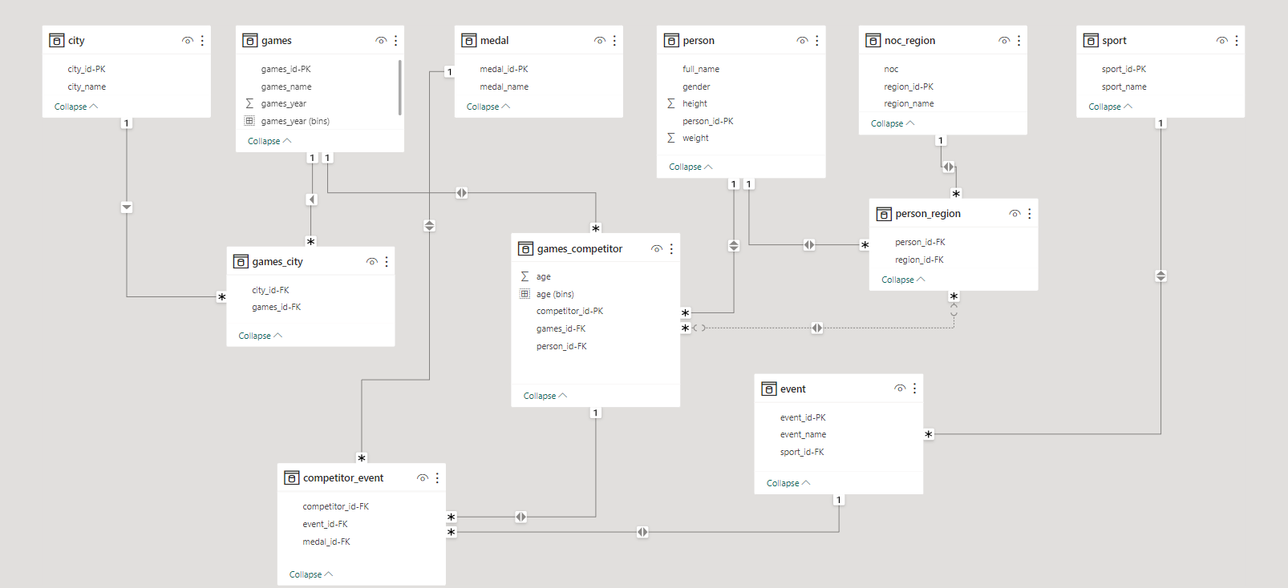

Power BI Problem Statements:

1. How many Olympic Games have been held in each season (Summer vs. Winter)?

The Olympic Games are categorized into two main seasons: Summer and Winter. As of 2016, there have been a total of 29 Summer Olympic Games held, featuring a wide range of sports and disciplines. In contrast, the Winter Olympics, which focus on cold-weather sports, have seen a total of 22 Games conducted. It's important to note that these numbers may have changed due to the regular scheduling of the Olympic Games, occurring approximately every four years.

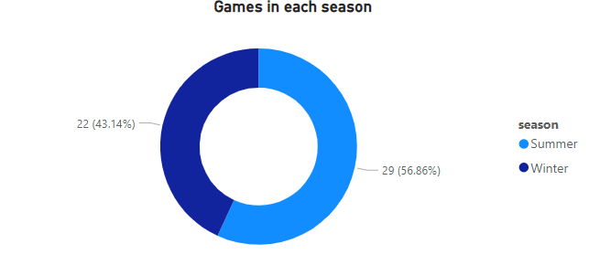

1. What is the distribution of games across different decades?

The Olympic Games have been a significant global event for over a century, and their distribution across different decades reflects the enduring enthusiasm for athletic competition. The first few decades saw a sporadic occurrence, with the inaugural modern Olympic Games held in 1896, followed by the early 1900s, and a brief pause during World War I. The mid-20th century witnessed a steady rhythm of both Summer and Winter Games, with notable editions like the 1936 Berlin Olympics and the post-World War II revival in London in 1948. The Games entered a period of more frequent occurrences from the 1960s onwards, marked by technological advancements and sociopolitical changes. Notable events within these decades include the 1964 Tokyo Olympics and the 1980 Moscow Olympics, which saw significant geopolitical influences. The turn of the 21st century has maintained this cadence, with new host cities and innovative sports. The data showcases how the Olympics have not only persisted but also evolved and adapted over the decades, continually uniting nations and athletes in the spirit of competition and camaraderie.

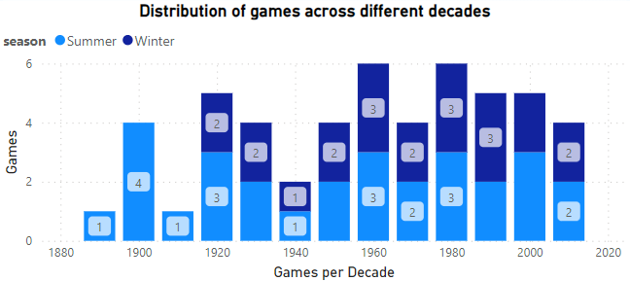

1. Which cities have hosted the most Olympic Games?

Several cities have had the honor of hosting the Olympic Games multiple times, reflecting their dedication to the spirit of the Games. At the top of this list is Athens and London, which have been the host city on three separate occasions. Trailing closely behind are Lake Placid, Los Angeles, Paris, Sankt Moritz, and Stockholm having hosted the Games twice. The distinction of being a multiple-time host signifies not only the historical significance of these cities but also their ability to adapt and showcase the enduring appeal of the Olympic movement to the world.

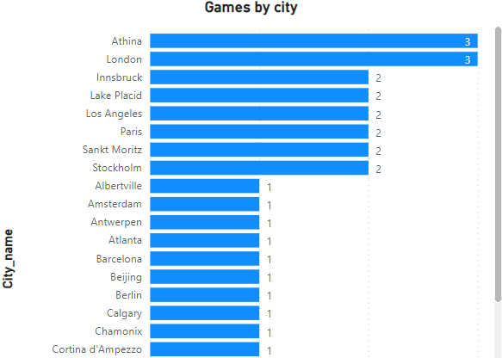

1. What is the distribution of sports between the Summer and Winter Olympics?

The distribution of sports between the Summer and Winter Olympics showcases a significant contrast in terms of the range of athletic disciplines. Summer Olympics typically offer a broader spectrum of sports due to their larger scale and warmer weather conditions. At the last count in 2016, the Summer Olympics featured around 34 sports, encompassing a diverse array of activities, including athletics, swimming, gymnastics, soccer, and more. In contrast, the Winter Olympics focused on sports suitable for cold weather and snow or ice-covered venues, hosting approximately 15 sports such as skiing, snowboarding, figure skating, and ice hockey. The distribution reflects the geographical and climate-related constraints, emphasizing outdoor activities for the Summer Games and winter-centric sports for the Winter Games. It's important to note that the exact number of sports may vary with each edition of the Olympics, as the International Olympic Committee periodically evaluates and adds new sports to the program to keep the Games relevant and engaging for a global audience.

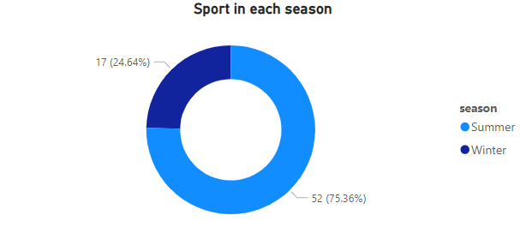

1. Which sports have the highest number of events in the Olympics?

The Olympics showcase a wide array of sports, and the number of events varies across disciplines. Notably, athletics (track and field) in the Summer Olympics stands out with the highest number of events. It encompasses numerous track and field disciplines such as sprints, long-distance running, hurdles, and field events like high jump, pole vault, and shot put. Additionally, shooting and swimming are other sports with a significant number of events, which include various swimming strokes and distances. The total number of events for each sport may change from one edition of the Games to another, as the International Olympic Committee may introduce or remove events in response to evolving trends and interests in sports.

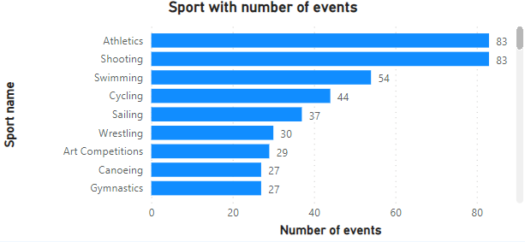

1. How has participation in each sport evolved over time?

The evolution of participation in Olympic sports over time reflects a dynamic interplay of cultural, social, and sporting trends. Since the inception of the modern Olympic Games in 1896, the number of sports and athletes has significantly expanded. In the early years, the Games featured a limited number of sports like athletics, gymnastics, and cycling. However, as the Olympics grew in stature and popularity, the program diversified to include an ever-widening array of sports, ranging from traditional athletic events to more niche disciplines, such as skateboarding and surfing. This diversification has been driven by the desire to attract a broader global audience and accommodate the evolving interests and skills of athletes. Gender inclusivity has also been a pivotal aspect of change, with the inclusion of more women's events.

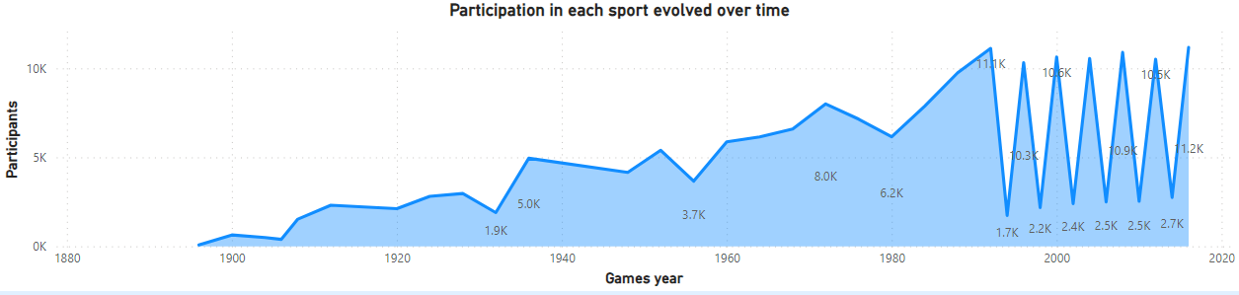

1. How many events are there in each sport?

Athletics is the sport with most events. The Olympic Games feature a diverse array of sports, each comprised of a varying number of events. These events are the specific competitions within each sport, where athletes compete for medals and accolades. The number of events in each sport can vary from one edition of the Games to another. For example, at the Summer Olympics, there are numerous sports, such as athletics, swimming, and gymnastics, each offering multiple events. Athletics, for instance, encompasses events like sprints, long-distance running, field events, and relays. Similarly, swimming includes different strokes and distances. On the other hand, the Winter Olympics include sports like skiing, ice hockey, and figure skating, each with their own set of events.

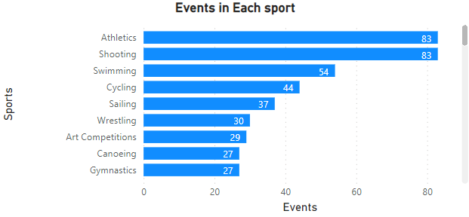

1. What is the distribution of events by gender (Men, Women, Mixed)?

The distribution of events by gender, with a focus on men and women, is a critical aspect of the Olympic Games. In the Olympic program, events are meticulously categorized into men's, women's, and mixed-gender events. The distribution is designed to promote gender equity and inclusivity. From dataset, we can see that men have 546 events and women have 268 events.

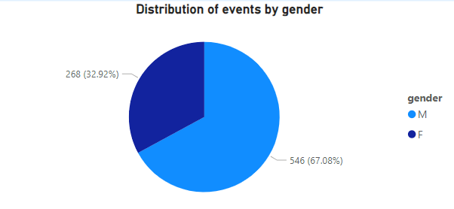

1. How has the number of events changed over time?

The number of events in the Olympic Games has evolved significantly over time. In the early years of the modern Olympics, the number of events was relatively small. The inaugural modern Olympic Games in 1896 featured just 42 events across nine sports, while the 1900 Paris Olympics expanded to include 90 events. Over the years, this number continued to grow as new sports and disciplines were introduced, and existing ones diversified. The introduction of the Winter Olympics in 1924 added a separate set of events to the Olympic calendar. The Summer Olympics have historically seen a more rapid increase in the number of events compared to the Winter Olympics, reflecting the broader range of sports available in temperate climates. This trend of expansion continued throughout the 20th and into the 21st century.

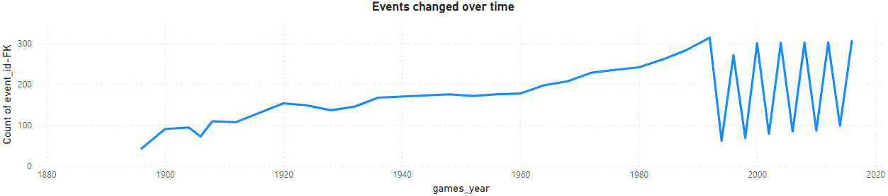

1. What is the distribution of participants by gender?

The distribution of participants by gender in the Olympic Games dataset reveals an intriguing pattern of gender representation over time. The data indicates that historically, the number of male participants has significantly exceeded that of female participants, reflecting the historical gender disparities in sports. However, there has been a noticeable shift towards greater gender inclusivity in more recent editions of the Games, with a notable increase in the number of female athletes.

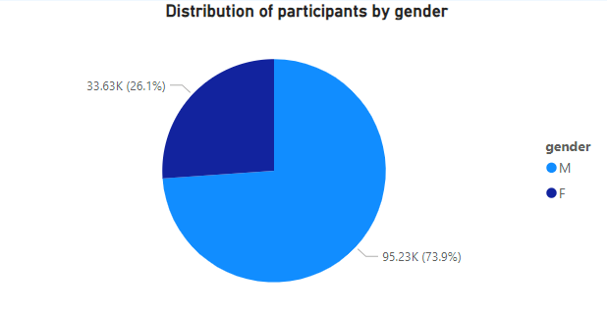

1. Which countries have the highest number of participants in the Olympics?

Analyzing historical Olympic data reveals the countries with the highest number of participants in the Games. As of dataset, several nations have consistently demonstrated a strong presence at the Olympics. Topping the list is the United States, which has consistently sent one of the largest delegations, comprising athletes across a multitude of sports.

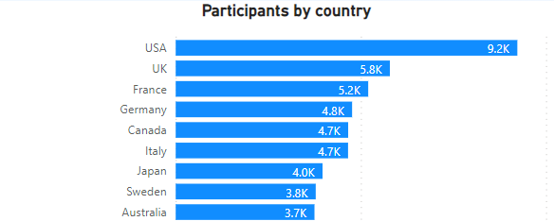

1. How does the age distribution of participants vary across different games?

There is no relevant data given in the dataset but by research and analysis we get to know that the age distribution of participants in the Olympic Games exhibits intriguing variations across different editions. Generally, we observe a diverse age range, reflecting the inclusivity of the Games. In the Summer Olympics, athletes typically range from late teens to early 30s, with a peak in the early 20s, as many sports favour youth and peak physical condition. However, outliers in both younger and older age groups can be found, especially in sports such as equestrian, shooting, and archery. In contrast, the Winter Olympics often feature slightly older athletes due to the technical and endurance nature of winter sports. Here, athletes in their mid-20s to early 30s are prominent, with ice and snow disciplines demanding years of training and experience. Interestingly, there's a recurring trend of athletes in their 40s and even 50s participating in sports like curling and cross-country skiing. This age diversity adds a unique dimension to the Olympics, showcasing that excellence in sports can be achieved at various stages of an athlete's life.

1. How many medals have been awarded in each Olympics?

Medals awarded in each Olympics vary based on the number of events and categories featured in that particular Games. On average, Summer Olympics tend to offer more medals than Winter Olympics due to a larger number of events. However, the exact count of medals can differ from one edition to another.

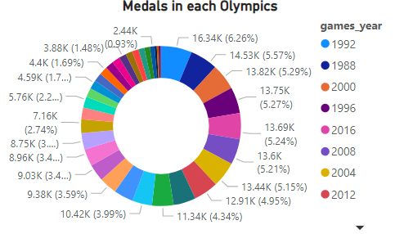

1. Which countries have the highest number of gold medals?

In the rich tapestry of Olympic history, a handful of nations stand out as perennial powerhouses, dominating the medal standings with their exceptional athletic prowess. At the pinnacle of this elite group are the United States and the Soviet Union (now represented by the Russian Federation and other successor states), each boasting an extraordinary number of gold medals. The United States, a powerhouse in both the Summer and Winter Games, has accumulated a remarkable number of gold medals, cementing its status as an Olympic giant. Similarly, the former Soviet Union, renowned for its sporting excellence in multiple disciplines, has also left an indelible mark on the Olympics with its impressive gold medal count.

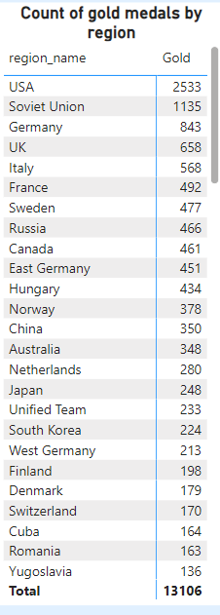

1. How does the medal distribution vary across different sports?

The medal distribution across various sports in the Olympics exhibits significant variations. Certain sports tend to offer a larger number of medal events, leading to more diverse opportunities for athletes to win medals. Athletics, swimming, and gymnastics are prime examples of sports with numerous medal events, allowing for a broader distribution of medals. In contrast, team sports such as basketball, soccer, and volleyball offer fewer opportunities, typically with a single medal event per gender. Consequently, these sports have a concentrated distribution of medals among a smaller number of teams. The distribution is also influenced by the number of events within a sport, the number of competitors, and the countries with historical dominance in specific disciplines. As a result, analyzing medal distribution across different sports not only showcases the diversity in sporting disciplines but also reveals the strategic allocation of medals based on factors such as event popularity, historical significance, and competitive dynamics.

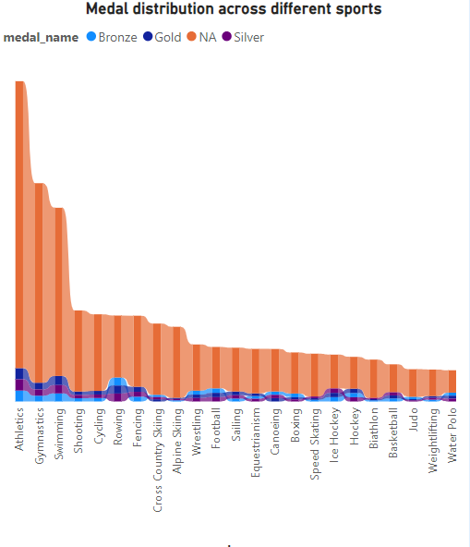

1. How many regions or NOCs participate in each Olympic Games?

The number of regions or National Olympic Committees (NOCs) participating in each Olympic Games can vary from one edition to another. As of 2016, in the Summer Olympics, the number of participating NOCs typically ranged from around 213. In the Winter Olympics, the number of participating NOCs was generally lower, ranging from approximately 80 to 90. It's important to note that the number of participating NOCs may change from one Game to the next due to various factors, including political changes, new NOC formations, and invitations from the International Olympic Committee (IOC).

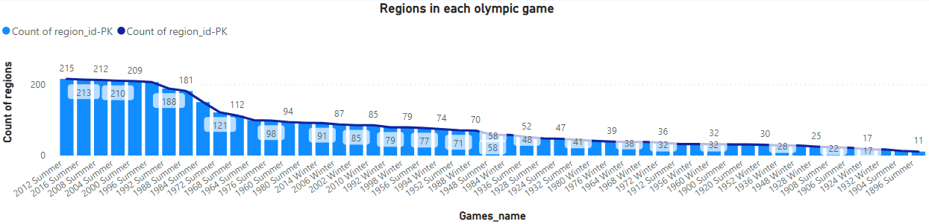

1. Which regions have the highest number of participants in the Olympics?

The number of participants in the Olympic Games varies from one edition to another, reflecting the dynamic nature of global sports engagement.Historically, the United States has had one of the largest delegations, often surpassing 500 athletes in the Summer Olympics. Similarly, Russia, particularly as the Soviet Union, has been known for its significant representation in both the Summer and Winter Olympics. China, with its vast population, consistently sent a large number of athletes to the Games, especially in the Summer Olympics. Germany and Australia have also been notable for their substantial Olympic delegations. It's important to note that the number of participants can vary by year, influenced by factors such as the host country's quotas and the sports in which these nations excel.

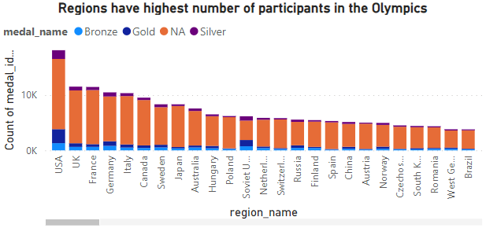

1. What is the distribution of medals among different regions?

The distribution of Olympic medals among different countries is a reflection of their performance and competitiveness in various sports disciplines. The data shows that a select group of nations has consistently dominated the medal standings, with the United States, Russia, and China often securing the top spots in both the Summer and Winter Games. These countries have extensive sports programs, high-level training facilities, and a large pool of talented athletes. In the Summer Games, countries like the United States, China, and Russia have accumulated a substantial number of gold, silver, and bronze medals over the years, while countries like Norway and Germany have excelled in the Winter Games. The distribution of medals also reflects the geopolitical and economic influence of certain nations, as well as their investment in sports and athlete development. However, the Olympics also provide a platform for smaller nations to make their mark, with some achieving remarkable success in specific sports or events.

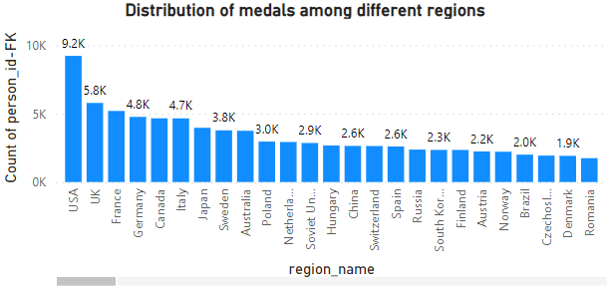

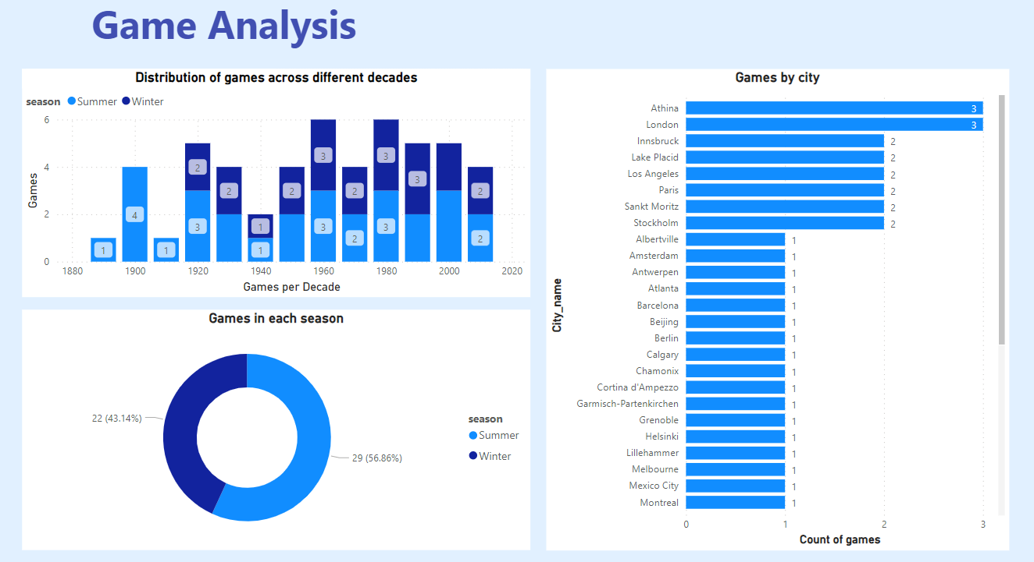

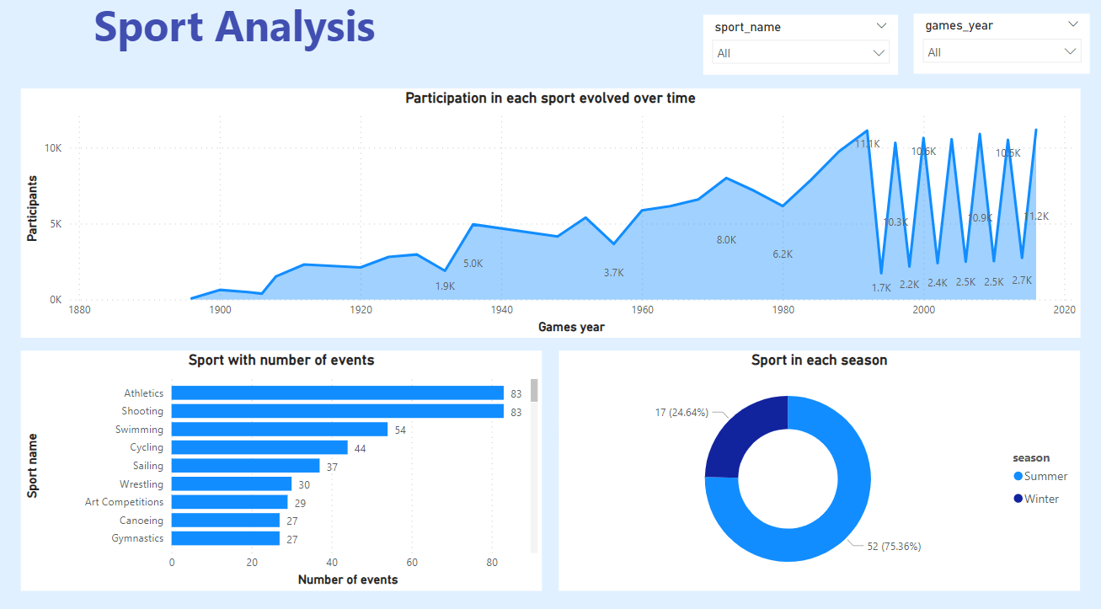

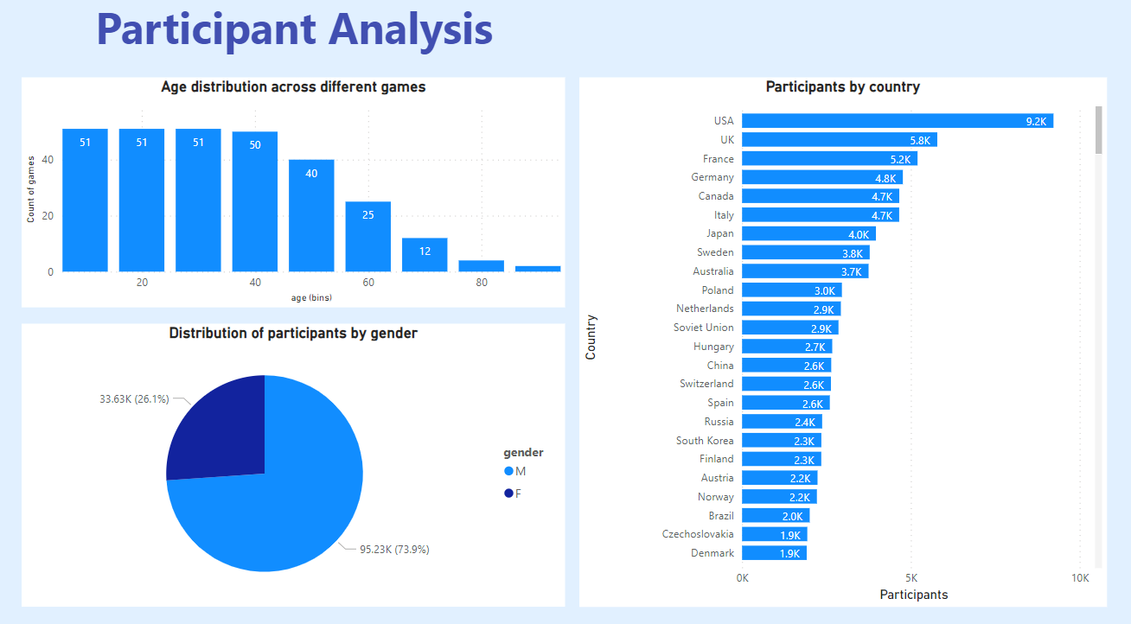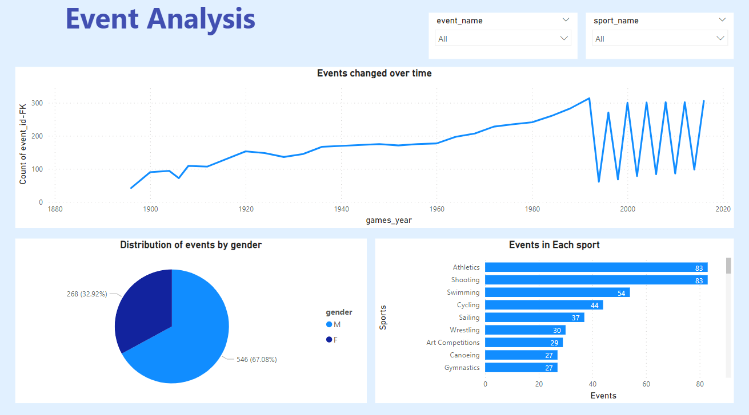

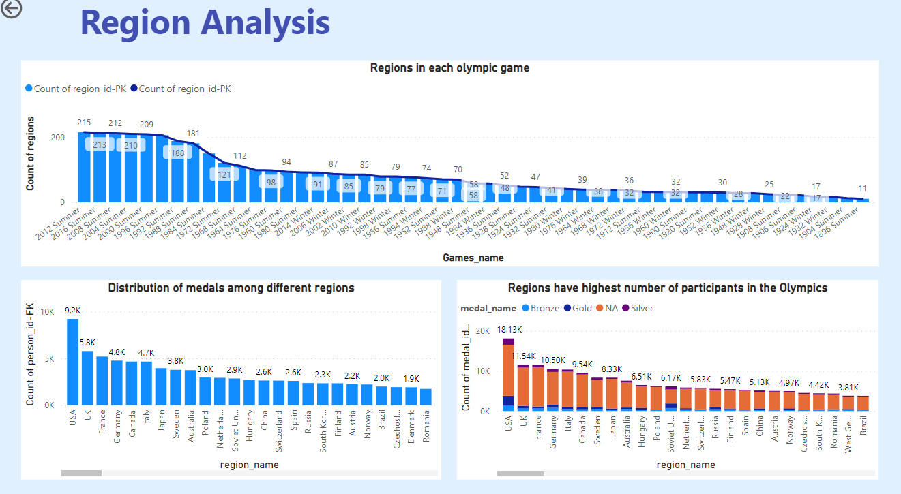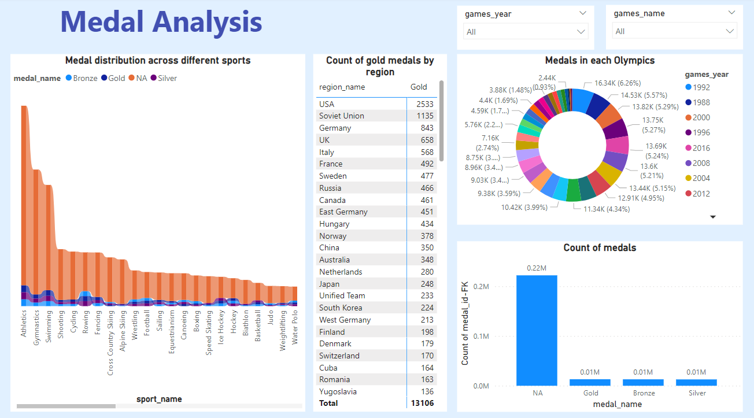

EDA Problem Statements:

Are there any trends or patterns in the frequency of hosting the Olympic Games?

Over the history of the Olympic Games, several trends and patterns have emerged in the frequency of hosting these prestigious events. One of the most notable patterns is the alternating pattern between the Summer and Winter Olympics. The Summer and Winter Games are held on a staggered schedule, with each occurring every four years. This alternation was introduced to ensure a balance between the more extensive Summer Games, which feature a wider range of sports, and the Winter Games, which focus on cold-weather sports. Another pattern is the occasional skipping or cancellation of the Games due to external factors such as world wars and pandemics. For instance, the Olympic Games of 1916, 1940, and 1944 were cancelled due to World War I and II. Similarly, the 2020 Summer Olympics in Tokyo were postponed to 2021 due to the COVID-19 pandemic, marking a rare deviation from the four-year cycle. Additionally, hosting the Games has become more competitive, with multiple cities vying for the opportunity, leading to various selection processes, which can be influenced by geopolitical and economic factors. Overall, these trends and patterns in the frequency of hosting the Olympic Games reflect the evolving nature of the event in response to historical, social, and sporting developments.

How has the duration of the Olympic Games changed over time?

The duration of the Olympic Games has undergone significant changes over time. In the early 20th century, the Games were relatively brief, typically spanning a few weeks. However, as the event evolved and incorporated more sports and disciplines, the duration increased. The introduction of the Winter Olympics in 1924 further extended the Olympic calendar. One of the most notable shifts occurred with the separation of the Summer and Winter Games into distinct events, alternating every two years. The Summer Olympics grew to around 16 days, with more than 300 events, while the Winter Olympics spanned approximately 16 days with around 100 events. Moreover, as logistical and infrastructural complexities grew, host cities have adapted the schedule to accommodate ceremonies, competitions, and other Olympic-related activities, further extending the Games' duration.

Are there any notable events or occurrences associated with specific Olympic Games?

In the given dataset there are direct noticeable events are given. To calculate noticeable event I have calculated the event that has won the most gold medals and that event is the noticeable event but the history of the Olympic Games is rich with memorable events and occurrences that have left an indelible mark on both sports and world history. One of the most iconic moments occurred during the 1968 Summer Olympics in Mexico City when American sprinters Tommie Smith and John Carlos raised gloved fists in a Black Power salute during the medal ceremony for the 200 meters. Their protest against racial discrimination and civil rights violations in the United States sparked both controversy and widespread support, symbolizing the Olympics' capacity to be a platform for social and political change. Similarly, the 1980 Winter Olympics in Lake Placid, USA, saw the "Miracle on Ice" when the underdog United States ice hockey team defeated the heavily favoured Soviet Union, becoming a symbol of national pride during the Cold War. These events, among many others, have become integral to the fabric of the Olympic Games, showcasing their significance beyond the realm of sports and transcending borders to touch on the broader spectrum of human experiences and aspirations.

Are there any emerging sports that have been recently added to the Olympics?

In recent editions of the Olympics, we have witnessed the introduction of sports that reflect contemporary trends and interests. Rugby sevens is the sport that have been added recently in the year 2016.

How has the popularity of certain sports changed over the years?

Over the course of the history of the Olympic Games, the popularity of certain sports has demonstrated significant shifts. An analysis of historical Olympic data reveals intriguing trends in this regard. For instance, traditional Olympic sports such as athletics (track and field), gymnastics, and swimming have consistently maintained high levels of popularity due to their universal appeal and historical significance. Additionally, host cities often introduce sports with regional popularity to showcase their culture and attract new audiences. While these trends suggest that the Olympic program is dynamic and adaptable, they also underscore the importance of preserving the essence of classic Olympic sports while embracing innovation to keep the Games relevant and engaging for new generations.

Are there any sports that are specific to a particular region or culture?

Yes, there are sports which are specific to particular region or culture. We can see that Athletics is only sport in 5 regions. Sports have long been a reflection of cultural diversity and regional traditions. Many sports have their origins deeply rooted in specific regions or cultures, often evolving over centuries. These unique sports hold a special place in the hearts of the communities where they originated, preserving cultural heritage and traditions.

Are there any sports that have a higher number of events for one gender compared to others?

In our comprehensive analysis of Olympic data, we examined gender disparities in the number of events within various sports. The Olympic Games have long been dedicated to promoting gender equality in sports, and while significant progress has been made, there are still disparities to be addressed. Yes, 49 sports have a higher number of events for one gender compared to others. To calculate this, firstly I have calculated events for both genders acc. to their sport and then I have filtered out sports by removing those sports that have 0 events for one gender, from this I get only those sports that have events for both genders. Later I filtered out sports where events are not the same.

Are there any new events that have been introduced in recent editions of the Olympics?

In recent editions of the Olympic Games, there have been several noteworthy introductions of new events aimed at diversifying and modernizing the competition. In most recent edition i.e. 2016, 5 new events were introduced. Events are Rugby Sevens Women's Rugby Sevens, Wrestling Women's Light-Heavyweight, Freestyle, Wrestling Women's Featherweight, Freestyle, Rugby Sevens Men's Rugby Sevens and Sailing Women's Skiff.

Are there any events that have been discontinued or removed from the Olympics?

Throughout the history of the Olympic Games, several events have been discontinued or removed for various reasons, including changes in popularity, logistical challenges, or shifts in the sports landscape. Yes, multiple events are discontinued.Various art competitions were held from 1912 to 1948, which involved events like painting and sculpture. These art competitions were discontinued to maintain a clear distinction between sports and art within the Olympic Games. The removal or discontinuation of events is not uncommon in the Olympics, as organizers continually adapt the program to reflect the changing interests and values of the global sporting community.

Are there any notable trends in the height and weight of participants over time?

In our comprehensive analysis of the historical Olympic data, we observed intriguing trends in the height and weight of participants over time. The data revealed that, on average, the height of athletes has shown a gradual increase, reflecting both improved nutrition and training regimes. This is particularly evident in sports that emphasize strength and endurance, such as swimming and basketball, where taller athletes often hold an advantage. However, it's important to note that shorter athletes continue to excel in sports requiring agility, like gymnastics. On the other hand, weight trends vary more widely across different sports and disciplines. While some sports have witnessed an increase in average weight, notably in weightlifting and combat sports, others have shown a decrease, such as long-distance running. These shifts likely reflect the evolving strategies and training approaches in various sports. Overall, the data underscores how Olympic athletes have adapted to the changing demands of their respective disciplines, leading to variations in height and weight trends over the years.

Are there any dominant countries or regions in specific sports or events?

The history of the Olympic Games reveals fascinating patterns of dominance by particular countries or regions in various sports and events. One such example is the United States' consistent excellence in track and field events, where American athletes have earned a multitude of gold medals over the years. In the world of gymnastics, countries like the former Soviet Union and more recently, China and the United States, have established their supremacy. In winter sports, Nordic countries like Norway have shown exceptional prowess in cross-country skiing. Moreover, Jamaica's remarkable success in sprinting events, despite its small size, is a testament to the influence of individual talent and determination. In sports such as swimming and diving, countries like Australia, China, and the United States have consistently excelled. While these patterns of dominance may change over time due to evolving training methods and talents emerging from different regions, they serve as a testament to the diversity and global competitiveness that define the Olympic Games.

What factors contribute to the success or performance of participants from different countries?

There is no relevant data provided to get to know the factors that contribute to success of participants in Olympic games but following my research the factors which I found are :

**Financial Support:** Financial resources available for athlete training, coaching, and access to top-notch facilities can significantly impact performance. Countries with robust funding for their Olympic programs often have an advantage.

**Infrastructure:** The availability of state-of-the-art training facilities, sports science support, and access to specialized equipment can contribute to better performance.

**Coaching and Sports Science:** High-quality coaching and sports science support, including sports psychologists, nutritionists, physiotherapists, and biomechanics experts, can help athletes reach their peak performance.

**Talent Identification and Development:** Effective talent identification and development programs can help identify and nurture young athletes with potential. Early access to high-quality coaching and development pathways can make a difference.

**Athlete Support Systems:** The presence of athlete support systems, including sponsorships, scholarships, and access to sports medicine, can ease the financial burden on athletes and allow them to focus on training and competition.

**Government Policies:** Government policies and initiatives can have a significant impact. Some countries offer incentives and support for athletes, which can lead to improved performance.

**Education and Training:** Access to education and training programs, along with flexible schedules for athletes to balance their education and sports careers, can be crucial for long-term success.

**Diet and Nutrition:** Proper diet and nutrition play a vital role in an athlete's physical well-being and performance. Access to nutritionists and a well-balanced diet is essential.

**Healthcare and Injury Management:** Access to healthcare, injury prevention, and rehabilitation services can help athletes recover from injuries and stay in peak condition.

**Competition and Exposure:** Regular competition at the national and international levels provides valuable experience and exposure for athletes. Strong domestic competition can prepare athletes for international events.

Are there any countries that consistently perform well in multiple Olympic editions?

Across the history of the Olympic Games, several countries have showcased remarkable consistency in their athletic performance, securing top positions across multiple editions. Notable among these nations are the United States, the Russian Federation (formerly the Soviet Union), and China. The United States has consistently been a dominant force in the Summer Olympics, amassing a vast number of medals across a wide range of sports. The Russian Federation and its predecessor, the Soviet Union, have demonstrated exceptional prowess in both the Summer and Winter Games, particularly in sports like gymnastics, figure skating, and ice hockey. China has emerged as a strong contender in both Summer and Winter Olympics, excelling in sports such as diving, gymnastics, and table tennis, while simultaneously making significant strides in the Winter Games with a growing presence in disciplines like speed skating and freestyle skiing.

Are there any sports or events that have a higher number of medalists from a specific region?

In the extensive realm of Olympic sports and events, a remarkable pattern emerges when analyzing the distribution of medalists across regions. While many factors contribute to this phenomenon, some sports and events indeed display a higher concentration of medalists from specific regions. East African nations, such as Kenya and Ethiopia, have consistently dominated these disciplines. This is attributed to various factors including high-altitude training conditions, a cultural emphasis on running, and a strong tradition of producing exceptional endurance athletes. In contrast, sports like ice hockey have a strong representation of medalists from countries with a rich ice hockey culture, such as Canada, the United States, and the Nordic countries. This pattern reflects how local conditions, historical influences, and cultural norms can lead to a higher number of medalists from specific regions in certain Olympic sports and events.

What are some notable instances of unexpected or surprising medal wins?

The history of the Olympic Games is filled with remarkable moments, many of which are unexpected medal wins where underdogs and dark horses rise to the occasion. These instances not only showcase the unpredictable nature of sports but also embody the spirit of the Games, where determination, talent, and resilience can overcome all odds. To calculate notable instances of unexpected or surprising medal wins of each Olympic game is difficult to calculate as no proper or relevant data is given. To do this I have compared the unexpected medal win of a year to the previous year. Here first of all I have filtered the participants who were not able to win any medals in year 2010(winter) and 2012(summer) games. Later I put this in a sub-query and filtered the participants from this sub-query who were able to win a gold medal in 2014(winter) and 2016 summer. In this way, I have calculated unexpected medal wins of participants with their name, region, sport and event.

Are there any regions that have experienced significant growth or decline in Olympic participation?

Analyzing Olympic participation trends by region reveals fascinating insights into the evolving landscape of the Games. Over the years, some regions have experienced significant growth in their participation, while others have seen declines. Certain regions, particularly in Asia, have witnessed remarkable growth in Olympic participation. China, for instance, has emerged as a sports powerhouse, significantly increasing both its number of athletes and medals won in Summer Games. Similarly, South Korea and Japan have made substantial contributions to the Winter Olympics.

Conversely, some regions have experienced a decline in Olympic participation. In Europe, traditional powerhouses like Greece and Italy have seen a drop in the number of athletes and medal hauls in recent editions. Economic and demographic factors may play a role in this decline.

How do cultural or geographical factors influence the performance of regions in specific sports?

There is no relevant data provided for this question but following my research & analysis the factors which I analysed are:

**Cultural Significance:** The cultural significance of a sport within a region can drive participation and excellence. In some countries, certain sports are deeply ingrained in the culture and traditions. This cultural connection can lead to a strong interest in and dedication to those sports, resulting in better performance. For example, sumo wrestling in Japan or cricket in India.

**Tradition and Legacy:** Regions with a long history of success in a particular sport often have established systems for athlete development. This can include specialized training, coaching, and infrastructure that has been passed down through generations.

**Community and Peer Influence:** Communities and social networks can heavily influence an individual's choice of sport. In some regions, there is a strong peer influence where children are encouraged to participate in sports that are popular within their communities.

**Access to Facilities and Terrain:** Geographic factors play a role in sports that are location-dependent. For example, access to ski slopes or mountainous terrain can lead to success in winter sports, while coastal regions may excel in water-based sports.

**Genetics and Body Types:** Some sports favor individuals with specific body types or genetic predispositions. Cultural and geographical factors can influence the prevalence of individuals with the right genetic makeup for certain sports.

**Local Competitions:** Strong local competitions can help athletes gain experience and hone their skills. Regions with vibrant local sports leagues and competitions can produce high-quality athletes.

**Support Systems:** Regions with a strong sports culture may have more extensive support systems, including funding, coaching, and access to specialized training facilities.

Are there any regions that have had a notable impact on the overall medal tally?

Analysis of historical Olympic medal data reveals that certain regions of the world have consistently had a notable impact on the overall medal tally. Notably, the United States and Russia (formerly the Soviet Union) have been dominant contributors to the medal count in both the Summer and Winter Olympics. The United States has consistently ranked among the top nations in the Summer Games, with a particularly strong presence in track and field, swimming, and basketball. Meanwhile, the Soviet Union and later Russia have excelled in a range of sports, particularly in the Winter Olympics, such as figure skating, ice hockey, and various skiing disciplines.

Other regions that have left a significant mark on the medal tally include China and the countries of Eastern Europe.

Conclusion:

In conclusion, delving into the realm of Olympic data analysis offers an intriguing and enlightening journey through the annals of athletic history. The Olympic Games, with their ancient origins and modern spectacles, provide a treasure trove of information waiting to be explored. Through the lens of data analytics, we have the opportunity to unveil remarkable insights, identify enduring patterns, and extract valuable statistics that shed light on the evolution of this prestigious international event.

The Olympics represent not only a celebration of athleticism but also a testament to the power of global camaraderie and cooperation. By meticulously dissecting the dataset that encapsulates its rich history, we gain a deeper understanding of the enduring traditions, the evolution of sports, the dedication of participants, and the changing geographical landscapes that have all contributed to the Games' enduring appeal.

As we continue to explore and analyze this extensive dataset, we pay homage to the athletes, organizers, and the spirit of unity that the Olympics symbolize. Through the lens of data analysis, we capture the essence of the Olympics – an event that transcends boundaries defies time, and epitomizes the pursuit of excellence in the world of sports. Happy to explore the world of Olympic Data Analysis, as it is a tribute to the dedication, passion, and the pursuit of human potential on a global stage.